Methods Summary: YC1 & YC2

General Design
- Instructional video preceding the execution of the task
- 50 (2 practice and 48 actual) object locations (excluding practice, 24 random locations, 24 counterbalanced locations) in a rectangular environment (1.8:1 aspect ratio)
- 3 trials for each location: 2 learning trials, 1 test trial
- Learning trial 1: subjects are placed at a random location at a given radius from the object. Subjects are smoothly turned to face the object (1 s turning), then automatically driven to the object location (3 s driving), then paused at the object (1 s).
- Learning trial 2: 5 s after learning trial 1, subjects are placed at a new random location and the process repeats.
- Test trial: subjects are placed at a random location and orientation, with the test object invisible. They navigate until they believe they are at the location of the object, and they press a button to record their response.
- ~45 s per object location, ~36 minutes total time

Task Schematic

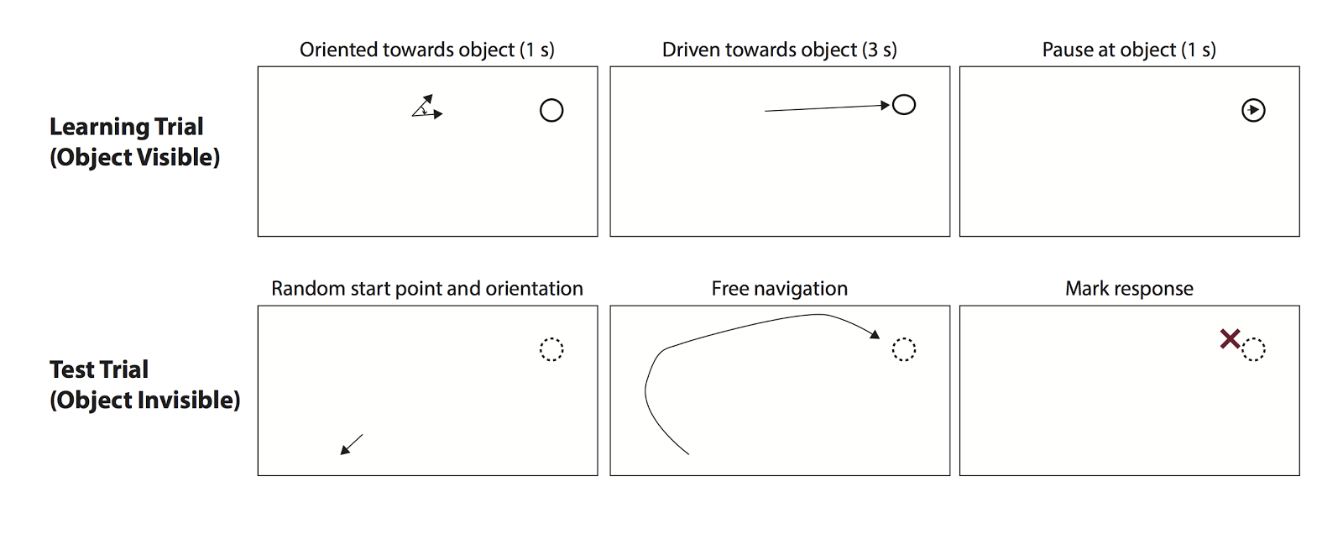

Stimulation Parameters
For the first cohort of participants, stimulation parameters (amplitude, frequency, and location) will be chosen to match stimulation from prior work showing stimulation-related enhancements in memory performance (Suthana et al., 2012). (Note: amplitude, frequency and location will be set manually by the clinician for System A).

Parameters fixed across first cohort of participants:
- Stimulation amplitude: 1.5 mA (or 0.5 less than afterdischarge threshold)
- Stimulation frequency: 50 Hz

Parameters varied within participant:
- Stimulation location: hippocampus and entorhinal cortex

Other Stimulation Parameters:
- Bipolar stimulation
- Pulse width: 600 microsecond pulse (300 us per phase)
- Duration: 5.0 s

Timing of Stimulation:
- Stimulation will be initiated at the onset of turning towards the object’s location. Simulation will be continuous for the 5 seconds of the learning trial (1 s turning, 3 s driving, 1 s waiting at the object location).
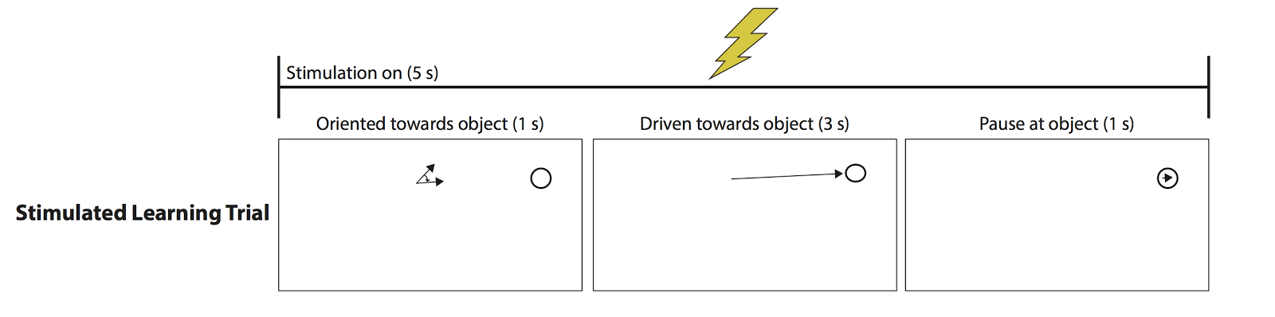
Assignment to stimulation condition:
- Half of the object locations will be assigned to the stimulation condition. Stimulated and unstimulated locations will be alternated. If an object is assigned to the stimulated condition, stimulation will occur during both of the associated learning trials.
- The region being stimulated will be switched at the midpoint of the a session. The order of hippocampus/EC stimulation conditions will be blocked within a participant and counterbalanced across participants. Blocking the design within participant will minimize time spent manually updating settings on the stimulator.

Counterbalancing stimulated and unstimulated locations:
- For every stimulated location, subjects will encounter an unstimulated location with reflected object position, starting positions, and orientations. Stimulated and unstimulated locations will be counterbalanced within each hippocampus and EC condition.
- This counterbalancing ensures that stimulated and unstimulated trials are difficulty matched. See diagram below.

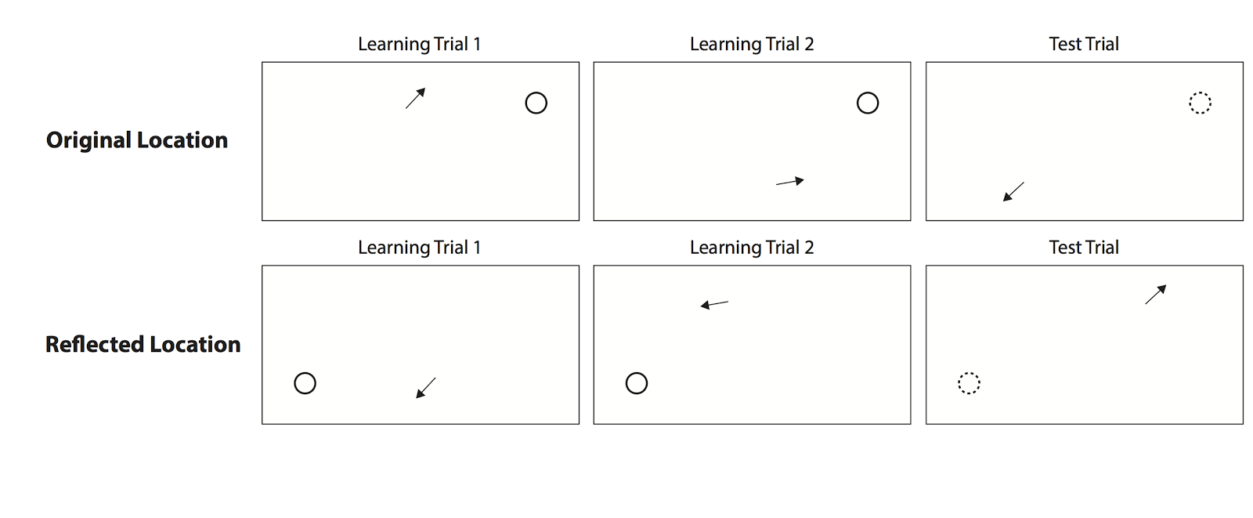Experimental Design Power Analysis
- Given an effect size 0.7 and 24 trials (12 stimulated and 12 non-stimulated) within a brain region, the experiment is powered at 0.73 probability for detecting an effect within a single session and region. If only one brain region is tested (24 stimulated and 24 non-stimulated trials), power is increased to 0.95 probability for detecting an effect of stimulation within a single session.
- The power analysis makes use of the fact that our counterbalancing scheme matches the locations and orientations used in each stimulated trial with reflected locations and orientations in a non-stimulated trial, allowing for the use of paired sample statistical tests.

References
- Suthana N, Haneef Z, Stern J, Mukamel R, Behnke B, Knowlton B & Fried I (2012). Memory enhancement and deep-brain stimulation of the entorhinal area. New England Journal of Medicine, 336, 502-510.

